Back Skills Training

Patient Workbook

Contents

Page
Introduction…………………………………………………………………………………………………………..3
Contents of each session……………………………………………………………………………………….5
Stretching & Strengthening Exercises…………………………………………………………………….6
Exercise log………………..………………………………………………………………………………………..10
Goals…………………………………………………………………………………………………………………….15
My Goals & Fitness goal………………………………………………………………………………………..16
Baselines……………………………………………………………………………………………………………….18
Tips on sleeping…………………………………………………………………………………………………….20
Tips on medication………………………………………………………………………………………………..21
Tips on communicating with health professionals……… ………………………………………..22

Group Sessions:

Session 1……………………………………………………………………………………………………………….23

Session 2……………………………………………………………………………………………………………….25

Session 3……………………………………………………………………………………………………………….27

Session 4……………………………………………………………………………………………………………….31

Session 5……………………………………………………………………………………………………………….36

Session 6……………………………………………………………………………………………………………….39
INTRODUCTION

What is the Back Skills Training Programme?
Back Skills Training helps people learn to manage their back problem better by learning about their backs and trying out different skills such as exercise and relaxation.

Why is this the best treatment for your back pain?
Traditional approaches to treat back pain have included ‘hands on therapy’, such as massage or acupuncture. You may have tried some of these treatments in the past. However, as our knowledge of back pain has improved, we now know that these traditional treatments often do not help in the long term. Since back pain often reoccurs over time, treatments that have a long term benefit are important. Therefore, the Back Skills Training programme focuses on teaching you about your back pain, and providing you with a range of skills and tools that you can use to manage your back pain over time. The Back Skills Training programme has been extensively researched, and has helped a large number of people to reduce their low back pain and improve their quality of life.

What do I have to do?
In order to get the most out of the programme, you should try to:
- Attend all video sessions
- Ask anything you want
- Do the home exercise programme
- Give activities at least a two-week trial
- Do the weekly homework tasks

How is the programme run?
There will be between 5 - 10 people in your group, both men and women. They will all be adults and have pain and troubles similar to yours. The groups will be run by a healthcare professional with specialist training.
Each session will include discussion with either the rest of the group or in pairs. You will not be picked out to speak but the clinician will encourage everyone in the group to participate if they would like to.
Each session is 1 ½ hours long. There will be a break in the middle for 10 minutes. This would be a good time to talk to the clinician about any problems that you are having with your exercises as they will not be covered in the group sessions. If you would like to do your exercises in this time you should wear suitable clothing.

DETAILS OF YOUR GROUP SESSIONS

The dates of your group sessions are outlined in your appointment letter.

CONTENTS OF EACH SESSION | Session 1 | Session  2 | Session 3 | Session 4 | Session 5 | Session 6
Overview of Back Skills  Training and Introductions | ✓
Understanding pain | ✓
The benefits of exercise | ✓
Time for break or stretches  and strengthening exercises | ✓ | ✓ | ✓ | ✓ | ✓ | ✓
Pain fluctuations |  | ✓
Working out your starting  point for exercises or activities |  | ✓
How to set goals |  | ✓
Unhelpful thoughts and  feelings |  |  | ✓
Relaxation |  |  |  | ✓ | ✓
Restarting activities or hobbies |  |  |  | ✓
When pain worries us |  |  |  |  | ✓
Coping with flare ups |  |  |  |  |  | ✓
This hopefully gives you a rough idea of what is involved in the Back Skills Training programme. If you have any questions, please ask!
STRETCHING EXERCISES

Back Bending
We are often told to avoid bending when we have back pain but this is not helpful. Our backs like to bend but if we have lost this movement it can be uncomfortable. Slow stretching into this movement eases twinges, enabling normal movement.

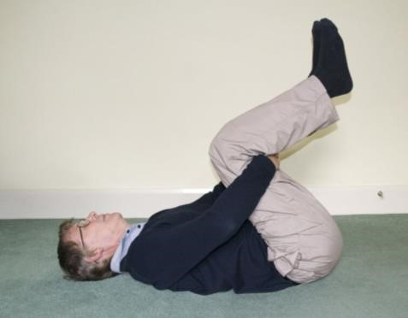  Option 1 | Lie on your back and bring both knees up to your chest with your legs bent.  Hug your knees into your chest so that your back has a good stretch.  Relax your arms and repeat.  Baseline:
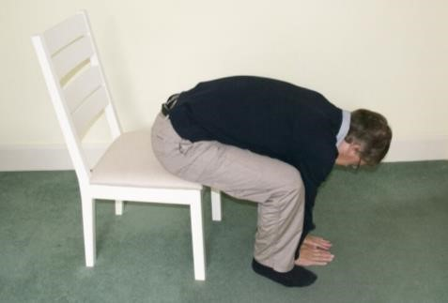  Option 2 | Sit on a firm chair, with your legs apart.  Slowly bend your head and back forwards, sliding your hands down the front of your legs.  Bring yourself back upright and repeat.  Baseline:
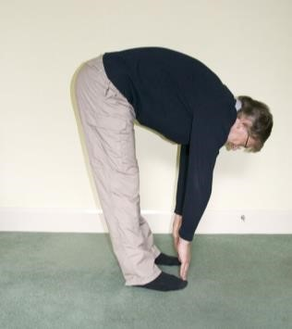  Option 3 | Stand with your feet hip width apart with your knees slightly bent.  Slowly bend your head and back forwards, sliding your hands down the front of your legs.  Bring yourself back upright and repeat.  Baseline:
STRETCHING EXERCISES
Back Twist
This is a movement the back likes to do but often gets stiff when activities are limited due to back problems. Doing this gentle stretch allows the back to move more normally.

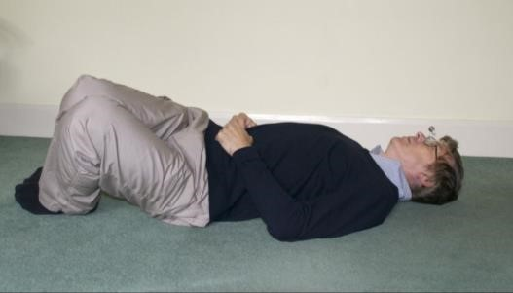  Option 1 | Lie on your back with both knees bent and your feet flat on the floor.  Your arms should be relaxed and slightly away from your body.  Slowly let both knees fall to one side, bring them back to the middle and repeat to the other side.  Baseline:
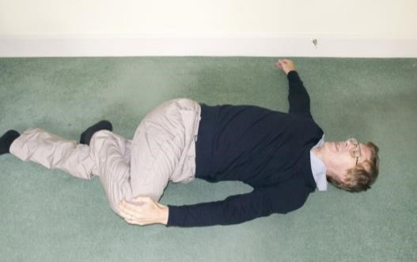  Option 2 | Lie on your back with one knee bent with the foot on the floor, and the other leg straight.  Relax your arms and place away from your body.  Slowly let the bent knee fall across the straight leg.  You can use your hand to help pull the knee down closer to the floor.  Bring your knees and arms back to the middle and repeat to the other side.  Baseline:
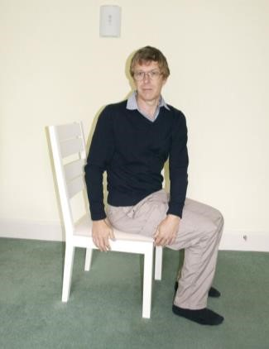  Option 3 | Sit on a firm chair.  Use your arms to start the movement and slowly twist your back around as far as you can so that you are looking behind you.  Repeat to the other side.  If this is comfortable and you want to make the stretch a bit stronger, use your hands to hold onto the back of the chair.  Baseline:
STRETCHING EXERCISES
Back Arching
We spend a lot of our day doing activities in a bent forwards position. Arching our backs in the other direction can improve our suppleness, meaning we are less likely to get twinges during everyday life.
Option 1  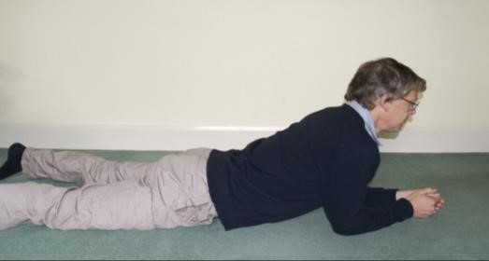 | Lie on your tummy with your elbows bent, hands and arms flat on the floor.  Push up with your hands and forearms so that your chest is lifted off the floor and your back is slightly arched. Your hands and forearms stay flat on the floor.  Lower yourself back down and repeat.  Baseline:
Option 2  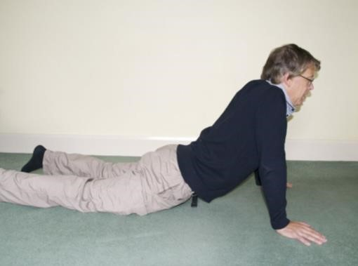 | Lie on your tummy with your hands on the floor by your shoulders, elbows bent.  Push up with your arms until your elbows are straight.  Your hips should stay on the floor as your back is arched.  Lower yourself back down and repeat.  Baseline:
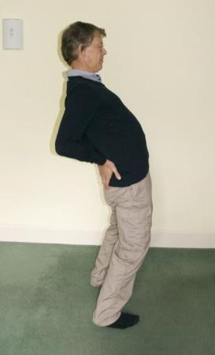  Option 3 | Stand with your feet hip width apart, hands on your back just above your bottom.  Slowly move your shoulders back and your hips forward as you arch your back.  Bring yourself back upright and repeat.  Baseline:

STRETCHING EXERCISES
Hamstrings (back of thigh)
If you have not been as active as usual because of your back problem, the hamstring muscles can tighten making you feel a bit stiff. Stretching the hamstrings allows the back to work more normally.

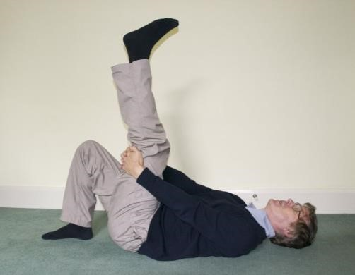  Option 1 | Lying on your back, bring one knee to your chest, supporting the back of your thigh.  Slowly straighten your knee as far as you can without moving your thigh.  Feel the stretch at the back of that leg.  Repeat with the other leg.  Baseline:
Option 2  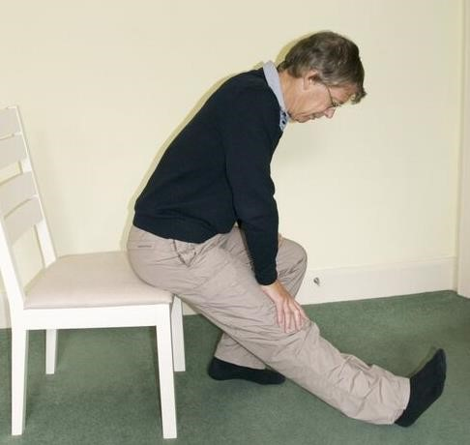 | Sit on the edge of a chair with one leg out straight, the other knee bent. Keeping your back straight, bend forward from the hips so you are reaching towards your knee. Look at something in front of you.  You can support yourself with your arms.  Repeat with the other leg.  Baseline:

STRENGTHENING EXERCISES
Sit to Stand
This is a wonderful exercise for strengthening your thigh and bottom muscles as it gets all the muscles working together as you get up and down from a chair.
Level 1  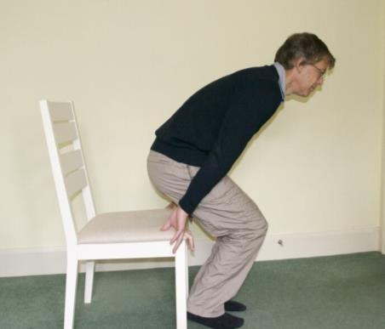 | Sit on an ordinary dining-type chair.  Stand up straight using your hands to help you (either by pushing on your thighs, on the arms of the chair or a table in front of you).  Slowly lower yourself back down onto the chair, again using your hands to help you.  Repeat.  Baseline:
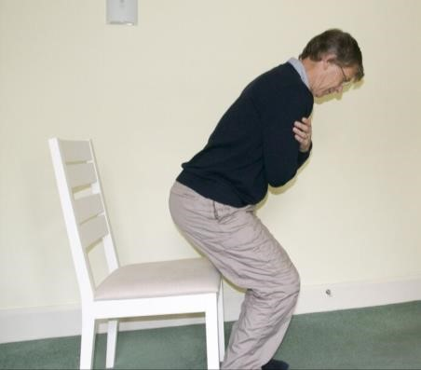  Level 2 | Sit on an ordinary dining-type chair.  Stand up without using your hands to help you.  Slowly lower yourself back down onto the chair again without using your hands to help you.  Repeat.  Baseline:
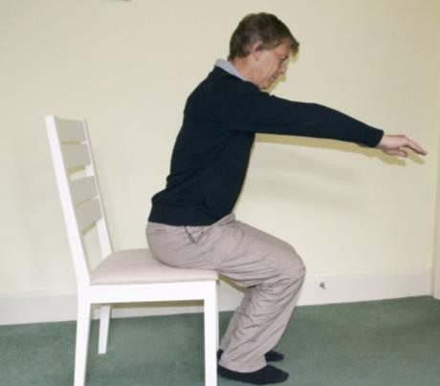  Level 3 | Sit on the edge of a sofa or on a low stool,  Stand up without using your hands to help you.  Slowly lower yourself back down onto the sofa or low stool without using your hands to help you.  Repeat.  Baseline:

STRENGTHENING EXERCISES

Tummy Curls
A great exercise for strengthening tummy (abdominal) muscles. Tummy muscles provide a ‘brace’ that helps your back move normally. This exercise will also make getting out of bed a lot easier.

Level 1  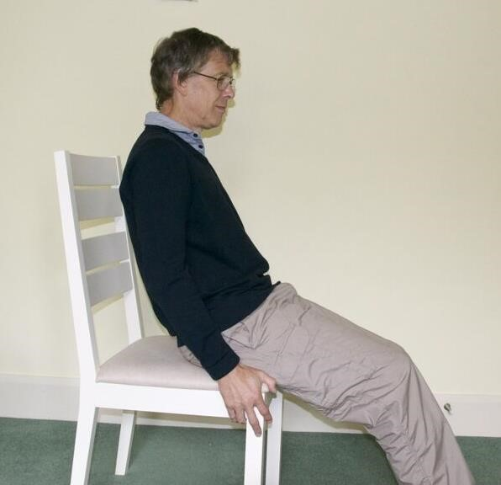 | Slowly lean back, keeping your bottom on the edge of the chair and feet flat on the floor.  When your head/shoulders touch the back of the chair, breathe in.  Tighten your tummy muscles and slowly bring yourself back upright. Do not jerk when doing this exercise.  Baseline:
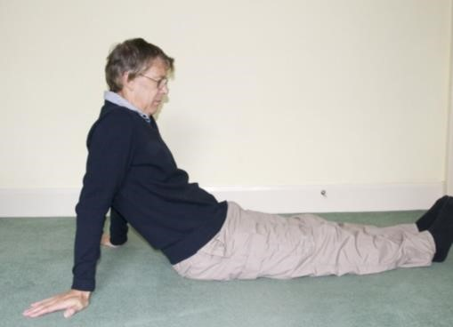  Level 2 | Sit on the floor or a bed with your legs out as straight as you can and with your arms straight out to the side.  Tighten your tummy muscles and slowly lean back at the same time as moving your arms back until your hands rest on the floor. Breathe in.  Tighten your tummy muscles and slowly bring yourself back upright. Do not jerk when doing this exercise.  Baseline:
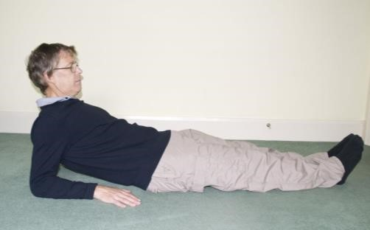  Level 3 | Sit on the floor or a bed with your legs out as straight as you can and with your hands resting on the side of your bottom.  Tighten your tummy muscles and slowly lean back keeping your hands on the side of your bottom until your forearms rest on the floor. Breathe in.  Tighten your tummy muscles and slowly bring yourself back upright. Do not jerk when doing this exercise.  Baseline:

STRENGTHENING EXERCISES
The Bridge
This exercise strengthens your tummy and bottom muscles as well as those in the back of your thigh (hamstrings) at the same time. These muscles support your body as you move around during the day.

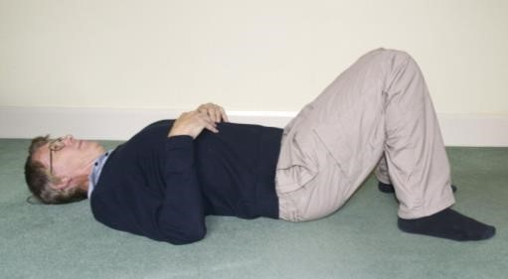  Level 1 | Tighten your tummy muscles and press the lower part of your back against the floor.  You know you are doing this right when your pelvis tilts towards you.  Baseline:
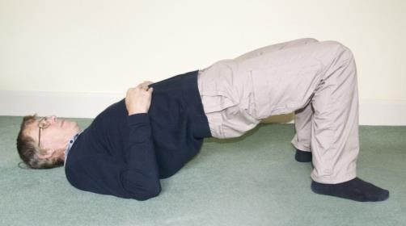  Level 2 | Tighten your tummy and bottom muscles.  Slowly lift your bottom off the floor until there is a straight line from your knees to your shoulders.  Slowly lower your bottom back to the floor.  Baseline:
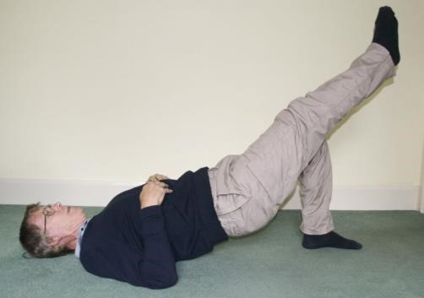  Level 3 | Tighten your tummy and bottom muscles.  Slowly lift your bottom off the floor until there is a straight line from your knees to your shoulders.  Holding this position, slowly straighten one leg by lifting the foot off the floor and keeping your knees together.  Return foot to floor. Repeat with the other leg.  Slowly lower your bottom back to the floor.  Baseline:

EXERCISE LOG

Please write down how many times you did the stretching and strengthening exercises every day.

If you didn’t manage to do the stretches on any day, please write down why.

Week | 1 | 2 | 3 | 4 | 5 | 6 | 7 | 8
Monday

Tuesday

Wednesday

Thursday

Friday

Saturday

Sunday

GOALS

Goals give you motivation and something to work towards. Think of things that you don’t do as much as you would like to or things that you have stopped doing completely.

How to set goals - some useful suggestions
- Chose a meaningful goal that will improve your life
- Be realistic about what you can do, and set a deadline for doing it.
- Break down goals into small steps that you can do
- Write goals down
- Reward yourself when you succeed
- If you don’t achieve your goal, learn from this; try breaking the goal down into smaller steps and measure your baseline again.

Once you have worked out your goal you will need to plan how you will reach the goal. For example if my goal was to mow the lawn once a week, then how would I break this down into tasks?
- Plan how to get mower out of garage
- Check the mower has enough petrol
- Plan how to start it – if need to pull a cord then plan to perform that movement without resistance to start with, building up speed and adding resistance
- Set a baseline of how long you can manage to push mower
- Plan how to empty grass cuttings e.g. start with container half-full • Plan how to put mower away

Some of these steps may need to be broken down further.
Use this sheet to start with your first goal. This should be a goal that will improve your fitness. You will most likely be working on this activity before the group sessions start.

MY GOALS

With your therapist work out two or three goals that you would like to work towards, these can be related to your fitness, work, or leisure:

1)_________________________________________________________________________________
___________________________________________________________________________________

2)_________________________________________________________________________________
___________________________________________________________________________________

3)_________________________________________________________________________________
___________________________________________________________________________________

Fitness goal

Goal:

___________________________________________________________________________________ ___________________________________________________________________________________

Baseline (Day 1 + Day 2 + Day 3 then divide by 3 and take a little off):

Stages or plan on how to increase:
___________________________________________________________________________________
___________________________________________________________________________________

Record how you get on with your fitness goal:

WEEK | How much done and how often
1
2
3
4
5
6
7
8
9
10
11
12

BASELINES

It is important to work out where to start for each exercise or activity. This is called setting a baseline.
Once you have worked it out it will help you to start at a level that is comfortable.

How to set a baseline…

- Day 1: Think about how much you feel you will be able to do. Try out this amount. Write down how many times you did the exercise or for how long you did it.
- Day 2: Think back on how Day 1 went. Change the amount if you need to, that is if it was easy try a little more, if it was difficult do a little less. Write down how much you did.
- Day 3: Think back on how Day 2 went. Change the amount if necessary. See what you can do.
Write down how much you did.

- Add together the amount you did on Days 1 – 3 and then divide this by 3.
Day 1 Day 2 Day 3 Total
 | + |  | +
=

Total Average

/ 3 =

Your starting point will be slightly less than your average in case we have overestimated how much you can do. For example if your average was 10 minutes walking, start by doing 7 or 8 minutes.

HOW TO PROGRESS FROM YOUR BASELINE

It is important to progress slowly. This will decrease the chance of overdoing it and having a pain flare-up.

- If you manage to carry out your baseline level of activity most days for 1-2 weeks then you can consider increasing by a small amount. For example, you could increase from 8 minutes of walking to 9 minutes.
- The diagram below shows how to build up in small increases to reach your target

Activity

Time

- This slow, steady approach to building up allows your body to adapt to the new activity
- If you experience an increase in pain after you have increased your activity level you could consider doing the following things:
  - Go back to the previous level and stay there for a little while longer before increasing again
  - Go back a little so that the increase wasn’t as much
  - Stay at the increased level a little while longer to see if your pain settles down (you may choose this option if you think the increase in pain was unrelated to the increase in activity)

TIPS ON SLEEPING
TIPS ON SLEEPING
The first thing to remember about sleeping is that the occasional night of disturbed sleep is normal and doesn’t cause us any problems. However, if you are regularly getting ‘poor’ sleep, try the tips below to see if they help – persevere with any changes as it may take a while before you feel the benefits.
- Try not to sleep during the day as this throws out your natural rhythm
- Make sure your bedroom is a good temperature - not too warm or stuffy, not too cold
- Try not to do things before you go to bed that wake you up or worry you, such as looking at bills or thing’s to do with work. Instead try something that helps you to ‘switch off’ such as watching T.V or reading a book
- Avoid spending lots of time on backlit devices such as smart phones or tablets in the hour before bed, as these can disrupt sleep patterns
- Taking a bath before you go to bed can help you relax, as can a warm drink. However, try not to drink any caffeinated tea or coffee after about 3 hours before you go to sleep as the caffeine can make it more difficult to get off to sleep
- Some people find a routine before they go to bed helps relax them
- If you find you are not falling asleep within 30 minutes, get out of bed and go and do something else that is not too stimulating until you start feeling sleepy and then go back to bed
- If you are having trouble getting off to sleep due to pain then you could try taking painkillers or changing the timing of when you take them so that they are at their most effective when you want to go to sleep. This is usually about 1 hour after you have taken them. If you wake up in the night due to pain as your painkillers have worn off you can speak to your G.P about changing to painkillers that last overnight
- If natural light is waking you early in the morning, you may need heavier curtains or lining

TIPS ON MEDICATION

- There are many types of medication that are prescribed to people experiencing back pain. e.g. pain killers, mood modifiers, sleeping tablets, muscle relaxants, and anti-inflammatories
- They can be a useful tool in the management of your back pain in order for you to be able to do more
- In general, people find that taking the full-recommended dose can be more effective. Also, if you wait until the pain is very high before you take anything, it may not work as well as if you take it earlier on. Try experimenting with this to find out what works best for you.
- In general, painkillers do not allow you to hurt yourself without knowing
- Not all medications suit everyone
- Sometimes medications can cause side effects such as: constipation, odd feelings, sleepiness, over alertness
- Consider reducing or stopping medication during good spells in discussion with your doctor
- If the side effects outweigh the benefits in pain relief, or if a medication just isn’t working for you then discuss this with your doctor who may advise you on coming off the medication or be able to suggest you try an alternative.

TIPS ON COMMUNICATING WITH HEALTH CARE PROFESSIONALS

TIPS ON COMMUNICATING WITH HEALTH PROFESSIONALS
- Remember that health care professionals have problems too. They work under many constraints, such as time limits and lack of information. Health care professionals feel frustrated that they can’t cure all health problems. They need to know why you are consulting them.
- Are you consulting a health professional for:
 Information  Analysis  Advice
 Understanding  Reassurance
- A suggestion of how to get the most out of visits to health care professionals e.g. doctors is given below.

Take PART
Prepare: | Prepare a written list of your MAIN concerns
Ask: | Ask questions about these concerns early in the visit so that they have time to answer them
Repeat: | Repeat back to the doctor the key points discussed during the visit. This gives both of you opportunity to correct any misunderstandings
Take action: | Take action if there are barriers to following the doctor’s recommendations and let
your doctor know

Session 1

Aims
- To meet group members and to find out about Back Skills Training
- To find out what you will learn over the six sessions
- To understand more about why we can have pain
- To understand the effects of inactivity on our bodies and the benefits of exercise 5. To monitor progress with the exercises and activity goal

Pain - key things to remember…
- Pain is a very valuable and necessary thing as it is part of the body’s protective system.
- Short lasting pain usually has a specific source and is limited as to how long it goes on for. It makes us protect the painful part, for example a sprained ankle – which is helpful.
- Long lasting pain is an on-going nuisance and is no longer helpful, it lasts for over 3 months and usually has no clear source or cause.
- Having pain that stops you doing things that you enjoy is linked to low mood, decreased activity and fitness, and also feelings of frustration.
- Research suggests that pain can persist due to changes in nerves which carry messages from our body to our brain about potential problems:
  - Nerves can fire on their own - so people can experience pain when doing nothing.
  - Nerves can become over-sensitive so even light touch can be felt as pain.
- It is our brain that decides, 100% of the time, whether we feel pain as a result of the messages it is receiving. In on-going pain the brain can become overprotective and we can experience pain with movements or activities that are not harmful, even in a stiff and weak back. This can be likened to an oversensitive smoke detector that goes off all the time.
- The changes that occur to the pain system can be improved.
- If we understand and manage our pain better, it can reduce over time.

Effects of inactivity and benefits of exercise…

Effects of Inactivity | Effects of Activity or Exercise
Weak muscles | Strengthen muscles
Stiff joints and muscles | Improved flexibility
Less fit - feel tired | More energy
Feel tense - muscles knot up | Wind down or relax
Feel fed up | Get a natural high – endorphins, bodies own painkiller
Put on weight | Lose or maintain weight

The flow diagram below shows how pain causes changes in our activity levels, usually by decreasing them. This causes physical changes such as stiff joints. When we are stiff and weak our back is likely to hurt more.
Breaking this cycle is important, you can do this by getting more active and by managing the pain better using the skills this course will teach you.

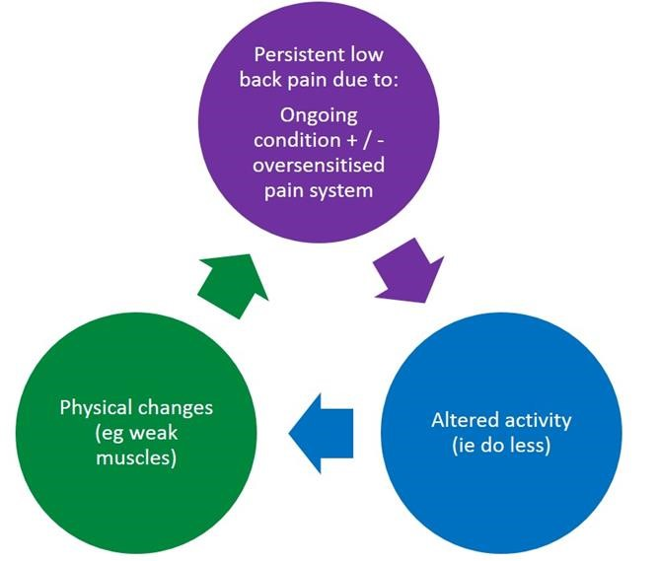

GROUP SESSION 2

Session 2

Aims
- To find out how the homework went (identifying some goals)
- To discuss how our activity levels change as our pain changes (over/under activity cycle).
- To discuss pacing
- To remind members about how to set baselines and goals

Pain fluctuations
- Pain often fluctuates up and down.
- As pain increases we tend to do less and the pain reduces.
- As pain reduces we then do more, causing our pain to go up again, as shown below:

HIGH

Do less
-

pain goes down

Do more
–

pain goes up

LOW

TIME

PAIN LEVELS

- Often the opposite is true as well - the less we do the more pain we get.
- When pain goes up and down it is difficult because it is hard to say what we will be like from one day to the next. This makes planning our lives very difficult.
- Getting stuck in over activity / under activity cycles can lead us to doing less over time.
- Avoiding these ups and downs is helpful and is called pacing.

Pacing
- Pacing means breaking up activity so that the day is divided into periods of relative rest and activity. It will help you manage the day better by keeping to your planned target
- Pacing is harder than it looks because we don’t tend to spread our activities and rest out evenly in this way. We would naturally do more when we had the energy and less when tired
- Pacing also means doing the activity whether feeling good or bad, not doing too much and not doing too little. The aim is keep an even level of activity over the day and week
- On a good day, you should not wait for pain to tell you when to stop. You should still stick carefully to your plan and avoid doing too much
- On a bad day try to keep going as planned but you could try to break up the activities more
- There are always times when you may wish to knowingly over-do it. For example, to attend a special event. This is OK. Over-doing it is unlikely to be harmful, even if you have to cope with increased pain for a while afterwards

Guide to pacing
Here are some ideas on how to pace. An example of house cleaning is given.
- Prioritise: What are the most important things that need to be done? What has to be done straight away and what can wait until another time
Example: House cleaning, living room first as friends coming over
- Plan: Try to plan the activities so those difficult ones are spread out and not done all in one go. What order is the best? Do you need help? Can you do them in a different way? Can you ‘chunk’ activities into those done in different positions?
Example: try spreading the vacuum cleaning out over several days. Could you sweep the kitchen with a brush, as it’s lighter than the vacuum cleaner?
- Tolerance level: Think about your baseline level for each activity of your plan, that is, how much of the activity can be done without overdoing it
Example: try and find the middle ground between what you would do on a good and on a bad day
- Evaluate: Try to stick to your plan. After several days carrying out this plan you should look back and decide if any changes need to be made
Example: if you had no problems with only vacuuming one room you could try doing two each time to see if this was ok

GROUP SESSION 3
Session 3

Aims
1. To find out how the goal setting and the baselines homework went 2. To introduce thought challenging

Unhelpful Thoughts
- Have you ever done too much knowing that it’s going to cause a flare-up? Or felt so fed up by the persistent pain that you don’t feel like trying and so give up on a certain activity?
- Research shows that when we are faced with a task or a situation it is the thoughts that we have about the situation that produces emotions (feelings), which then drive what we do (our actions or behaviour). We don’t seem to ‘act on impulse’ even if it feels like that sometimes
- The way that we think in a situation is different for every one of us and depends on what has happened to us before or what we have learned from others. For example if someone had arranged to meet a friend at a café at a certain time and they didn’t turn up, he or she could think ‘something’s happened’. This would make them feel worried and they might act on this by trying to phone around. Another person in the same situation may think ‘they have forgotten’ which could make them feel irritated and they would act by not waiting and walking off
- We could say that if our behaviour has been unhelpful, then the thought behind it was an unhelpful thought. In this way, it is worth tackling unhelpful thoughts about our back pain, to prevent us managing it in unhelpful ways

• We need to bear in mind that our thoughts don’t always reflect what is really going on – they can just be thoughts we are having
• Unhelpful types of thoughts about back pain could include:
- Black and white thinking: I can’t do it the way I used to so I might as well not bother
- Catastrophising: I can’t cope with the pain any more
- Should/Must Statements: I should be able to vacuum clean the whole house
- Jumping to conclusions: My back always plays up when I sit in a restaurant (only been once). They think I’m making it up
- Mental filter: Arthritis gets worse over time
- Critical self: I’ve got myself into this mess. Even my thinking is wrong!

Homework: Identifying thoughts
Use the blank table on the next page to try to identify any unhelpful thoughts you have, how they make you feel, and behave/act, and if you can come up with an answer back thought to say to yourself, the next time you have the unhelpful thought.
An answer back thought is usually a more balanced or helpful way of thinking and should make sense to you. If you have trouble thinking up an answer back thought, try to think what you might say to a friend in the same situation, or what a helpful friend might say to you.
The table below gives some examples.
Situation | Thought | Feeling | Behaviour/ action | Answer Back Thought
Seeing the hovering needs doing | I can’t do it  I can’t risk it | Frustrated  Nervous | Avoid hoovering. Ask someone else to do it. | It will be difficult but I can do it if I stick to my plan to spread it out.
Wake up with pain | There’s no point,  I’m no better  I might as well give up | Fed up | Spend day in bed.  Eat chocolate! | My pain is the same but  I’m doing more  I’ll get on top of this like I have other thing’s before.
In the garden, the lawn needs doing | I should be able to do this  I used to do the whole lawn in one go | Annoyed | Carry on & do the whole lawn (cause flare-up). | I’ll do it in my own time It doesn’t matter if it doesn’t get finished today
G.P says he can’t do anything to help | It must be all in my head. I should just push through it. | Low  Determined | Don’t tell  anyone when  I’m suffering. | I know (and I’ve been told) this is a real problem that I need to learn how to manage.

Situation | Thought | Feeling | Behaviour/ action | Answer Back Thought

Session 4

Aims
- To feedback on thought monitoring homework
- To understand about fear of movement and activities in long lasting low back pain 3. To practice two relaxation techniques

Avoidance of movement or activity

When we’ve hurt our backs there seems to be typical movements or activities that cause pain when we do them. As a result we naturally avoid doing them in the early stages as it hurts too much to ignore it. When we’ve avoided something for a long time, we can get into this vicious cycle:

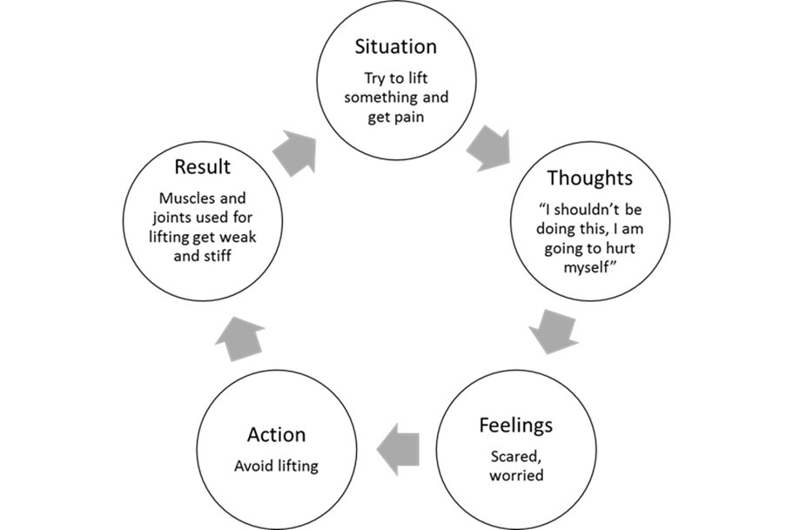
The weakness and stiffness that results from generally avoiding a movement can actually increase the amount of pain we feel when we next try to do the movement or activity – a vicious cycle.

Homework: Re-starting a feared movement or activity
Try to think if there is anything that you have avoided doing since your back pain started such as bending, lifting, or twisting and then plan how you could restart the activity with the aim of returning to your previous levels if this is possible. Make each stage easy! What’s important is that you feel confident with each stage before you move on.

Activity:…………………………………………………………………………………………………………………………………………………

Plan to restart (stages):
…………………..…………………..……………………………………………………………………………………………………………… ………………………………………………………………………………………………………………………………………………………… ………………………………………………………………………………………………………………………………………………………… ………………………………………………………………………………………………………………………………………………………… ……………………………………………………………………………………………………………………………………………..………… …………………………………………………………………………………………………………………………………………………………

Relaxation
What is relaxation?
Relaxation reduces tension. Tension is our bodies’ reaction to stress. This can make your pain feel worse. Relaxation can cut into the horrible cycle of pain, tension, more pain, more tension, and can stop pain getting worse.
Do I need special equipment?
The best relaxation skills are those you can use anytime, anywhere and in any position. For example, if you are stuck in traffic and feel your muscles tensing, then you need to be able to start your relaxation skills sitting down. The best way to become good at relaxation skills is to practice them at first when your pain is not too bad so that when the pain is worse you know what to do.
Why do I find relaxing difficult?
Most people find relaxing difficult, as it is not something that we normally do. We often feel that we don’t have the time to relax or that spending time relaxing is a waste of time. For this reason ‘relaxing’ is often linked with being ‘lazy’. You need to make time for yourself to practise relaxation, as it is an important tool in managing your pain.
Here are the first two skills for you to try out…

a) Deep Breathing
Deep breathing is one of the easiest relaxation techniques to learn. When we become stressed, one of our body’s fight or flight reactions is shallow, rapid breathing. Taking deep, slow breaths is one way we can turn off this fight or flight reaction. Deep breathing is the starting point for many other relaxation exercises.
- Wherever you are, put one hand on your tummy, just below the rib cage
- Slowly breathe in through your nose. You should feel your tummy rising and expanding outwards
- Breathe out slowly through your mouth, emptying your lungs completely and letting your tummy fall. Some people find saying ‘relax’ either in their head or out loud as they breathe out is helpful
- Make sure your shoulders are relaxed; you can check this by pulling them up to your ears and then dropping them down
- Repeat the tummy breathing several times until you feel relaxed

b) Stretch / relax muscle relaxation
This skill involves either tensing or stretching parts of your body in turn, followed by relaxing that part of your body. Some people prefer to tense their muscles, others prefer to stretch them. It may also depend on the body part. You can begin with either your head or your feet. You tighten or stretch the muscles for 5-8 seconds and then the tension is released. While releasing the tension, try to focus on the changes you feel when that part of your body is relaxed.

- Start this technique with some deep breathing as described on the previous page
- If you decide to start with your lower body, firmly tense or stretch your toes and hold the tension. Then, very slowly, release the toes.
- Now, move up to your feet. Pull your toes up towards you, hold the tension, and then slowly release the feet.
- Moving up to your knees, press your knees down onto the floor, or stretch your legs out to straighten your knees, hold the tension and then slowly release
- Continue the tensing or stretching and releasing until you reach the top of your head.
- You can tense and relax both sides at the same time or one at a time.

Use the log on the next page to record how well these relaxation exercises work for you when you try them.

Relaxation Log

Date | Relaxation Skill | How did the practice go?

Session 5

Aims
- To feedback on relaxation
- Review the homework on feared movements or activities.
- Discuss the effects of worrying about pain.
- To practice the other two relaxation techniques

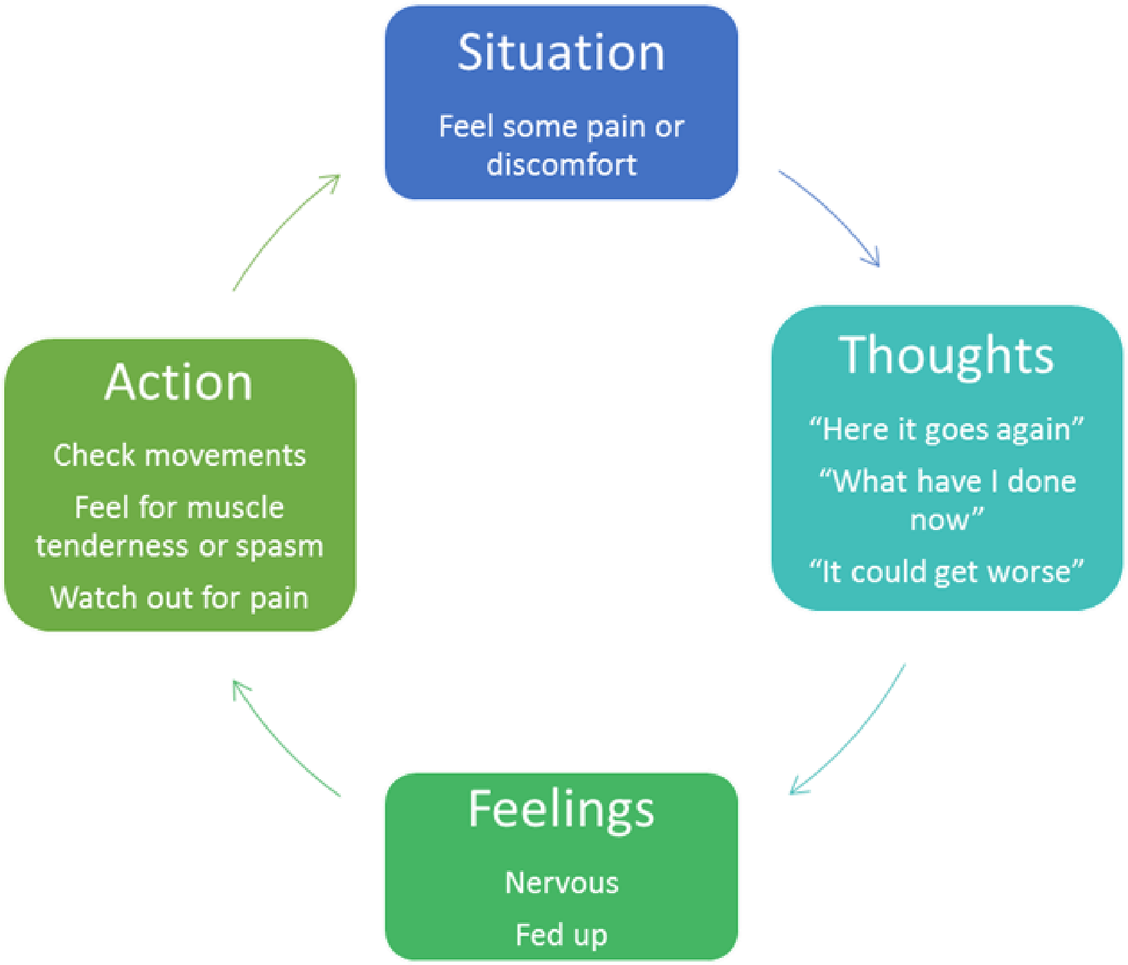
Worry about pain and its effects

As we saw in the last session, it’s very easy to get into vicious cycles when we are in pain. Another cycle can be described by thinking about how loud a clock sounds when we listen to it or when we are worried about the time. Pain is the same and this cycle is shown below:

Homework: Distraction
Try to think of what ways you currently use to distract yourself, for example watching a good film, reading, or using a hot water bottle.
Are there any other tips that you’ve picked up from the rest of the group? Try these out and see how they work for you.

Distraction techniques:

1) ________________________________________________

2)________________________________________________

3)________________________________________________

4)________________________________________________

5)________________________________________________

Further Relaxation Techniques

The first 2 relaxation techniques were described on Pages 37-38.

c) Visualisation or Imagery
To relax through visualisation, close your eyes and create a relaxing scene with your mind’s eye. So, if you enjoy relaxing at the beach, create a beach scene. If you prefer a garden, then create a garden scene. Create the scene by thinking about what you can see around you, smell, hear, taste, and feel.
The use of visualisation can help trigger the same relaxation you feel when you are actually there.
Start this technique by doing some deep breathing (page 37).
If you find the beach a place of relaxation, perhaps you’d see the blue water and sky, white sand and caps of waves, and green palm trees.
You’d likely hear the waves, the seagulls, and the wind.
You’d smell and taste the salt in the air.
You’d feel the smoothness and the wetness of the water and the grittiness of the sand.
You’d likely experience a sense of peace and serenity.

d) Autogenic Relaxation
Autogenic relaxation uses both visual imagery and body awareness. You focus on different physical sensations, moving from the feet to the head. You might focus on warmth and heaviness in the limbs, or imagine a red warm dot moving from your toes up and around your body spreading warmth along its way

Start this technique with some deep breathing (page 37) Become aware of how your right arm is feeling.
As you take slow relaxed breaths in and out say in your head, my right arm is feeling heavy….. my right arm is feeling heavier…….my right arm is feeling warm…….
Then move onto your other arm and repeat the steps
Then repeat for each leg
Return at the end to focussing on your breathing, taking slow deep breaths

Try out these two skills and record in your relaxation log how helpful you find them.

Session 6

Aims
- To feedback on distraction homework
- To discuss coping with flare ups
- To go back over some of the skills learned in the group

Coping with flare-ups
What would be a good plan for good spells?
- Progress exercises and goals
- Add new goals
- Reduce medications
- Enjoy yourself
- Plan ahead
- Stay active
- Practice relaxation

What would be a good plan during a flare-up?
- Carry on
- Review baseline
- Review medication
- Set goals
- Relaxation
- Allow personal time
- If possible identify triggers, learn from it and plan for next time. However, often there is no cause.

Homework: Personal flare-up plan
Temporary flare-ups to your back problem are bound to happen sooner or later so we encourage you to work out a plan of how you will cope with these flare-ups so you can put it into practice as soon as it is needed.

When I feel I’m having a flare-up I will:

- ________________________________________________________________
__________________________________________________________________ __________________________________________________________________

- ________________________________________________________________
__________________________________________________________________ __________________________________________________________________

- ________________________________________________________________
__________________________________________________________________ __________________________________________________________________

- ________________________________________________________________
__________________________________________________________________ __________________________________________________________________

- ________________________________________________________________
__________________________________________________________________ __________________________________________________________________

- ________________________________________________________________
__________________________________________________________________ __________________________________________________________________

